**Heart Disease Caused By Congenital Defects**

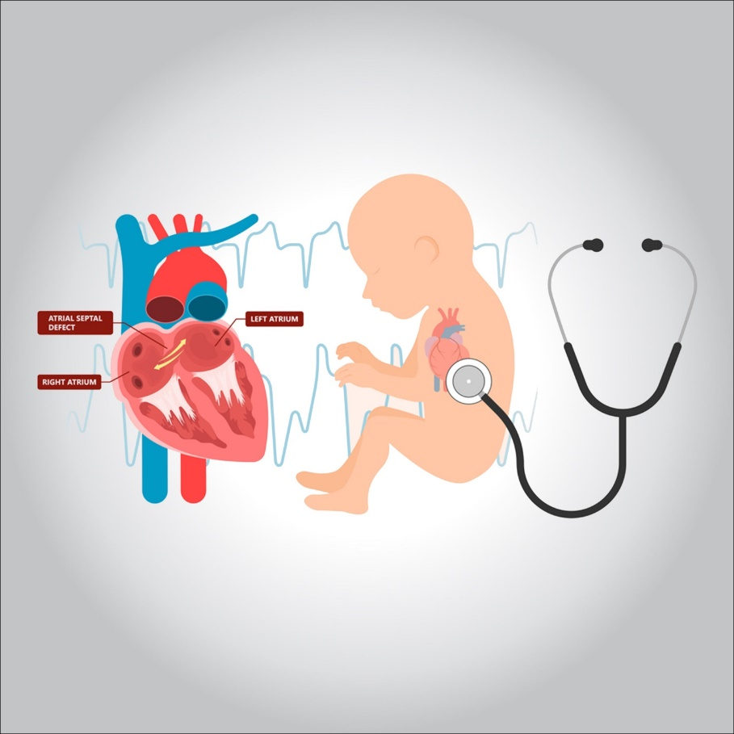

**Congenital heart disease is one or more problems with the structure of the heart that are present from birth. Being congenital means that you were born with it. Congenital heart disease — also called a congenital heart defect — can change the way blood flows through your heart. Some birth defects do not cause any problems**

**Reasons**

**The cause of congenital heart disease is often unknown. Risk factors include certain infections during pregnancy such as rubella, use of certain medications or drugs such as alcohol or tobacco, inbreeding, or having a malnourished or obese mother. Having a parent with congenital heart disease is also a risk factor**

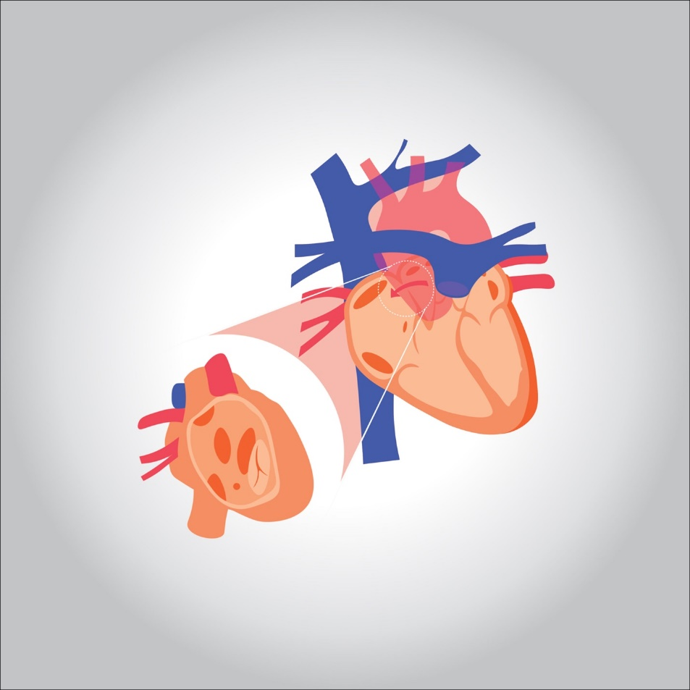

**Symptoms**

**Some congenital heart defects cause no signs or symptoms. In some cases, signs or symptoms of the disease appear later. Symptoms can return years after receiving treatment for heart defects.**

**Common symptoms of congenital heart disease in adults include:**

**Abnormal heartbeat (arrhythmia)**

**Bluish color to the skin, lips, and nails (cyanosis)**

**Shortness of breath**

**Tired quickly on exertion**

**Swelling of body tissues or organs (edema)**

**Protection**

**Children are more likely to develop congenital heart disease if their parents have it. Your doctor may suggest counseling or genetic testing if you plan to have children.**

**Psychiatric treatment**

**Congenital heart disease can be partially prevented by giving rubella vaccines, iodized salt, and adding folic acid to certain food products. Some diseases do not need treatment. Others may be effectively treated with catheter procedures or heart surgery.**